HR SERVICES
1. What is the NTG FTE Cap for your Agency?

DPC has FTE cap of 90.00 positions.

The actual Full Time Equivalent (FTE) increased to 100.6 in March 2011 from an actual FTE of 94.0 in June 2010

The approved FTE for DPC is 97.0 in 2011 and was 97 in 2010. An increased from approved FTE of 85 in 2009.

The increase in approved FTE in 2010 include:

    - 2 Port Service Workers
    - 3 Marine Service Officers
    - 1 Control Tower Officer
    - 2 Marine Pilots
    - 3 Administration staff
    - 1 Executive Contract Officer

Actual FTE includes 4 staff on extended Leave and 1 casual recorded as an FTE of 1.0.

2. As of 30 March 2011, what is the current FTE staffing of the department, by level?

The actual Full Time Equivalent (FTE) increased to 100.6 in March 2011 from an actual FTE of 94.0 in June 2010

The approved FTE for DPC is 97.0. The approved FTE in 2010 was 97 increased from 85 in 2009.

Actual FTE includes 4 staff on extended Leave and 1 casual recorded as an FTE of 1.0.

DPC has increased its staffing since June 2010

Classification | Nominal FTE | Actual FTE
AO2 | Admin Off 2 | 2.00
AO3 | Admin Off 3 | 1.00
BM | Board Members | 0.00
CTO | Control Tower | 4.05
EO1C | Exec Off 1 Cntr | 4.00
EO2C | Exec Off 2 Cntr | 2.00
EO4C | Exec Off 4 Cntr | 1.00
MPL1 | Marine Pilot 1 | 4.00
MPL3 | Marine Pilot 3 | 3.00
MPL4 | Marine Pilot 4 | 2.00
MSG2 | Security Guards | 13.00
MSO1 | Service Officer | 5.00
MSO2 | Service Officer | 1.00
MSO2X | Service Officer | 3.00
PAO1 | Port AO1 5 Week | 1.00
PAO2 | Port AO2 5 Week | 1.00
PAO3 | Port AO3 5 Week | 4.00
PAO3S | Port AO3 6 Week | 0.00
PAO4 | Port AO4 5 Week | 3.00
PAO4S | Port AO4 6 Week | 1.00
PAO5 | Port AO5 5 Week | 1.53
PAO6 | Port AO6 5 Week | 2.00
PAO7 | Port AO7 5 Week | 2.00
PAO7S | Port AO7 6 Week | 1.00
PAO8 | Port AO8 5 Week | 2.00
PPO2 | Port Prof 2 5 Week | 1.00
PPO4S | Port Prof 4 6 Week | 1.00
PSW1 | Port Srv Worker 1 | 1.00
PSW2 | Port Srv Worker 2 | 3.00
PSW3 | Port Srv Worker 3 | 7.00
PSW4 | Port Srv Worker 4 | 13.00
PSW5 | Port Srv Worker 5 | 5.00
PSW7 | Port Srv Worker 7 | 3.00
PSW8 | Port Srv Worker 8 | 3.00
DPC Total |  | 100.58

3. Is this figure in line with the NTG FTE Cap? If not, please explain

DPC has FTE at 30 March 2011 was 100.58. The FTE cap is 90.00

- DPC FTE cap was set below its approved establishment. The cap was sent based on actual average FTE in the March quarter of 2010.
- Increases to the established positions had been approved but had not been recruited to at this time.
- This included two Marine Pilot positions. Recruitment to these roles has long lead times due to the majority of applicants being overseas and/or working at sea.
- A number of positions at DPC operate a 24/7 365 day a year roster and the Corporation can not provide services without ensuring all these positions are filled.
- The actual Full Time Equivalent (FTE) increased to 100.6 in March 2011 from an actual FTE of 94.0 in June 2010
- The approved FTE for DPC is 97.0. The approved FTE in 2010 was 97 increased from 85 in 2009.
- Actual FTE at 31 March 2011 includes 4 staff on extended Leave and 1 casual recorded as an FTE of 1.0.

4. How many permanent positions are there in your department?
97 plus 3 Board Members. This includes 90 permanent positions and 7 Executive Contract positions.

5. How many of these positions were nominally filled and how many were filled by persons acting in positions or are temporary appointments?

DPC has actual FTE of 100.58 and Approved FTE of 97.00 (90 Permanent positions)

DPC has 71 positions filled nominally

DPC has 21 positions filled by Temporary Contract
  - 3 Board members
  - 1 LT workers compensation (not working)
  - 8 Executive Contract (includes MPL4 on four year contract)
  - 1 Casual Marine Pilot (employed for one week only)
  - 2 Marine Pilots ( on Temporary contract due to Visa restrictions)
  - 2 Temporary MSG( due to staff on higher duties within DPC)
  - 1 PSW8 (nominal position held my employee on long term sick leave)
  - 1 PSW (nominal position recently vacated. Employee transferred to Apprenticeship)
  - 2 PSW positions (Positions under review prior to permanent recruitment. Positions advertised May 2011

DPC has 16 positions filled temporarily by Permanent staff
  - 14 employees are Permanent DPC staff
  - 2 employees are from other NTG agencies
  - 2 employee on Temporary Higher Duties behind staff on Maternity Leave
  - 1 employee on Temporary Higher Duties behind Leave without pay
  - 1 employee on Temporary Higher Duties pending position undergoing JES review prior to advertising
  - 3 employee on short term higher duties in temporary supernumerary positions
  - 7 staff on Temporary Higher duties consequential to other staff on Higher Duties
  - 2 supernumerary employees (one extended unpaid leave

Please separate by permanent/temporary/acting by level:

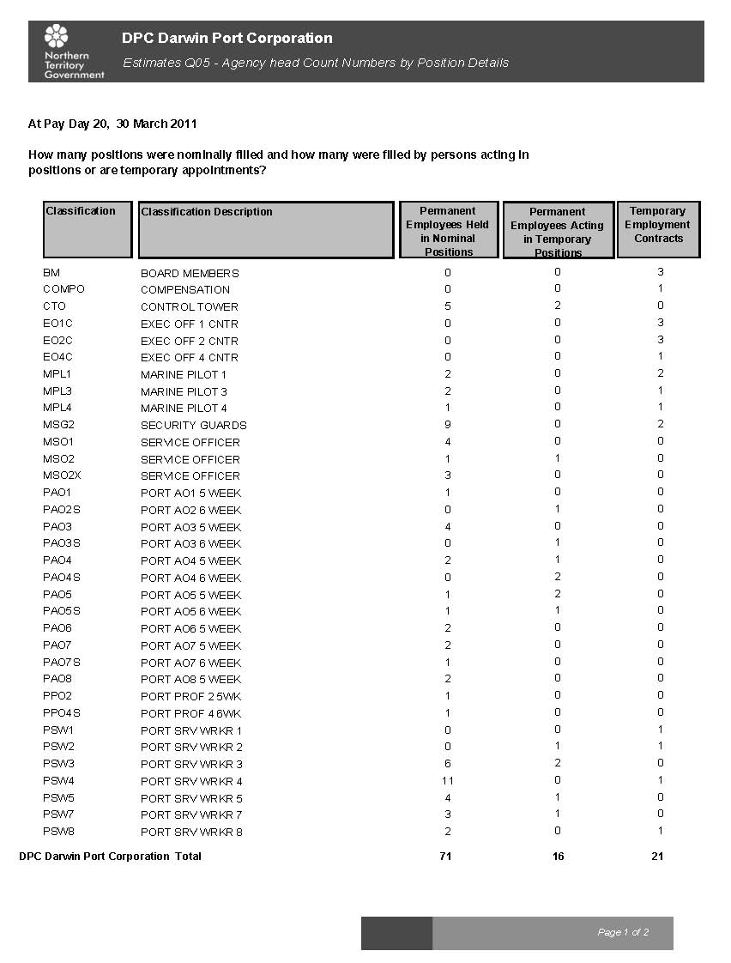

6. What was the turnover rate of staff in the Agency in 2010?

14.51%

7. What is the rate per level?

Turnover by level is high due to there being very few employees at each level.

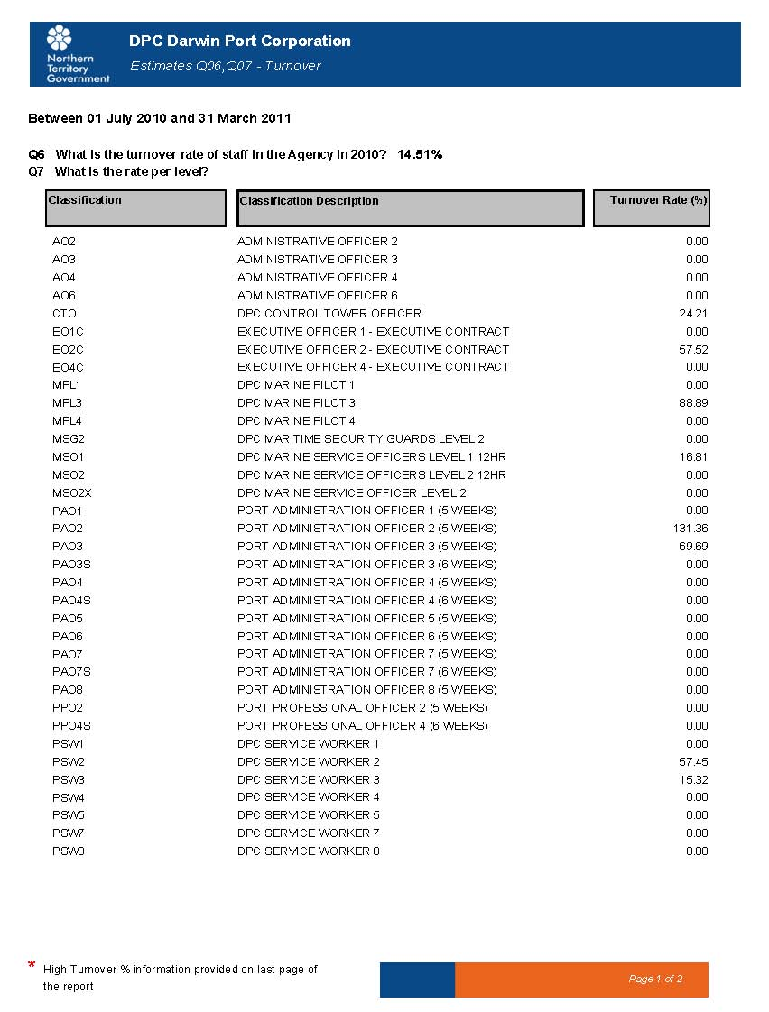

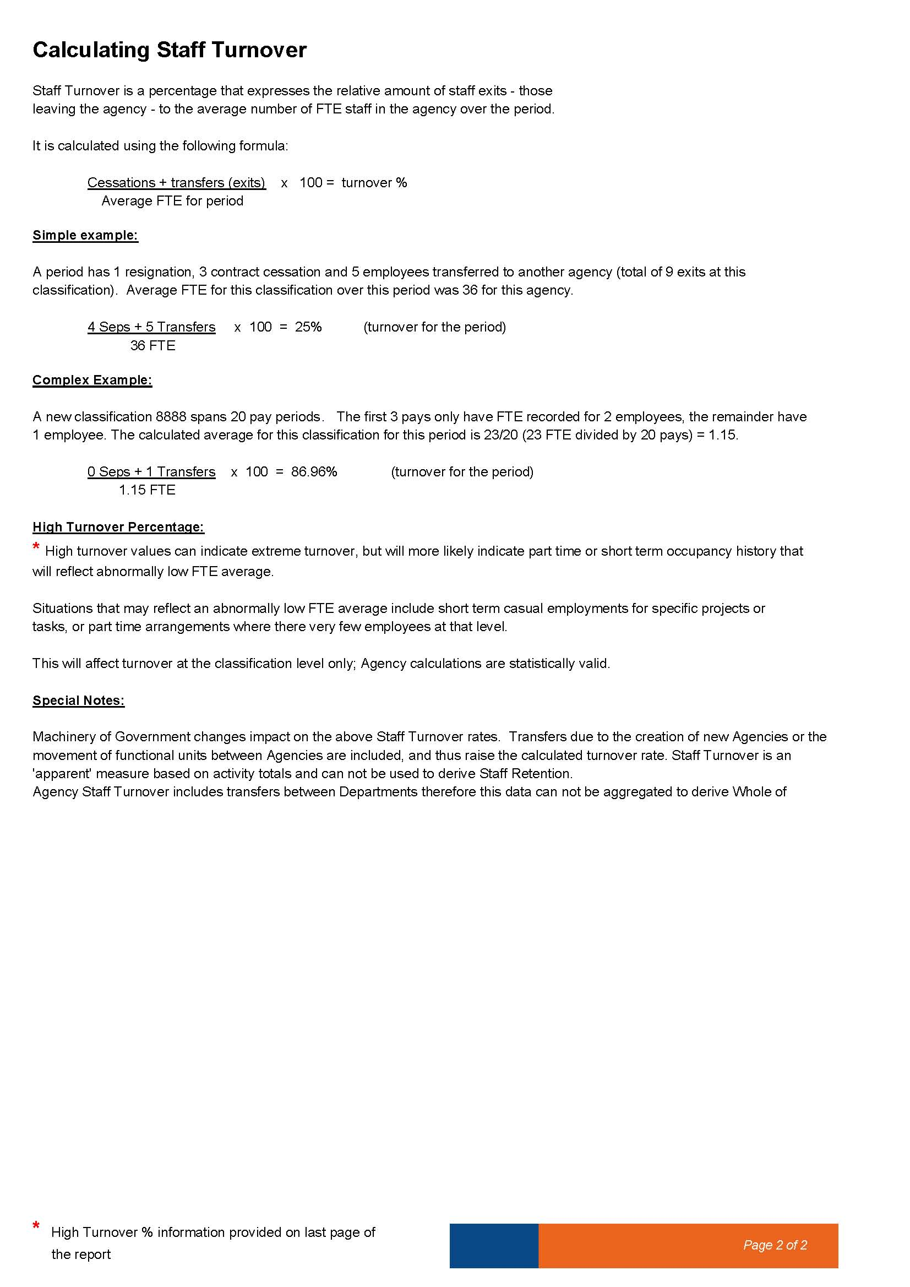

8. How many vacant positions are there in the Agency as a whole?

2

9. How long, in total days, have nominal positions been vacant in the department?

DPC small staffing requires that position be filled in a temporary capacity whilst they are nominally vacant.

DPC current reporting system does not allow it to fully identify the number of day’s position are vacant.

10. How many staff are currently employed on a temporary contract?

DPC has 21 positions filled by Temporary Contract
  - 3 Board Members
  - 1 LT workers compensation (not working)
  - 8 Executive Contract (includes MPL4 on four year contract)
  - 1 Casual Marine Pilot (employed for one week only)
  - 2 Marine Pilots (on Temporary contract due to Visa restrictions)
  - 2 Temporary MSG (due to staff on higher duties within DPC)
  - 1 PSW8 (nominal position held by employee on long term sick leave)
  - 1 PSW (nominal position recently vacated. Employee transferred to Apprenticeship)
  - 2 PSW positions (positions under review prior to permanent recruitment. Positions advertised May 2011).

11. In the period 30 March 2010 to 30 March 2011, how many temporary contracts have been extended, broken down by level and the number of times extended?

DPC have extended Temporary Contracts 9 times.

6 of contract extension in PSW1, PSW2 and PAO2 levels. These are DPC entry level positions. Contracts are consequential to short term vacancies created by staff on leave and temporary transfers.

1 employee has had 3 contract extensions. Two as a consequence of employees on Temporary transfers. The third extension was following resignation of another employee within group. Position advertised for permanent recruitment in May 2011.

12. In the period 30 March 2010 to 30 March 2011, how many positions have been advertised by “expression of interest”?

For the period 1 July 2010 to 30 March 2011 1 position was advertised by “expression of interest”

13. In relation to all vacant positions, what is the breakdown of recruitment actions by:

2 Recruitment processes open at 31 March 2011. One Temporary and one Permanent. Both positions have been filled

2 Vacant positions at 31 March 2011 (One filled through recruitment process above. Second position advertised in May 2011)

14. Per position level, what is the average length of time taken for recruitment from advertising to successful applicant?

Average of 61 days

Average has been distorted as a consequence of one position taking 101 days. This position was held up when an appeal was lodged against the vacating employee. This appeal was unresolved for a number of months.

15. What is the number of positions that have been filled by the recruitment of an existing public servant, and how many from the general public?

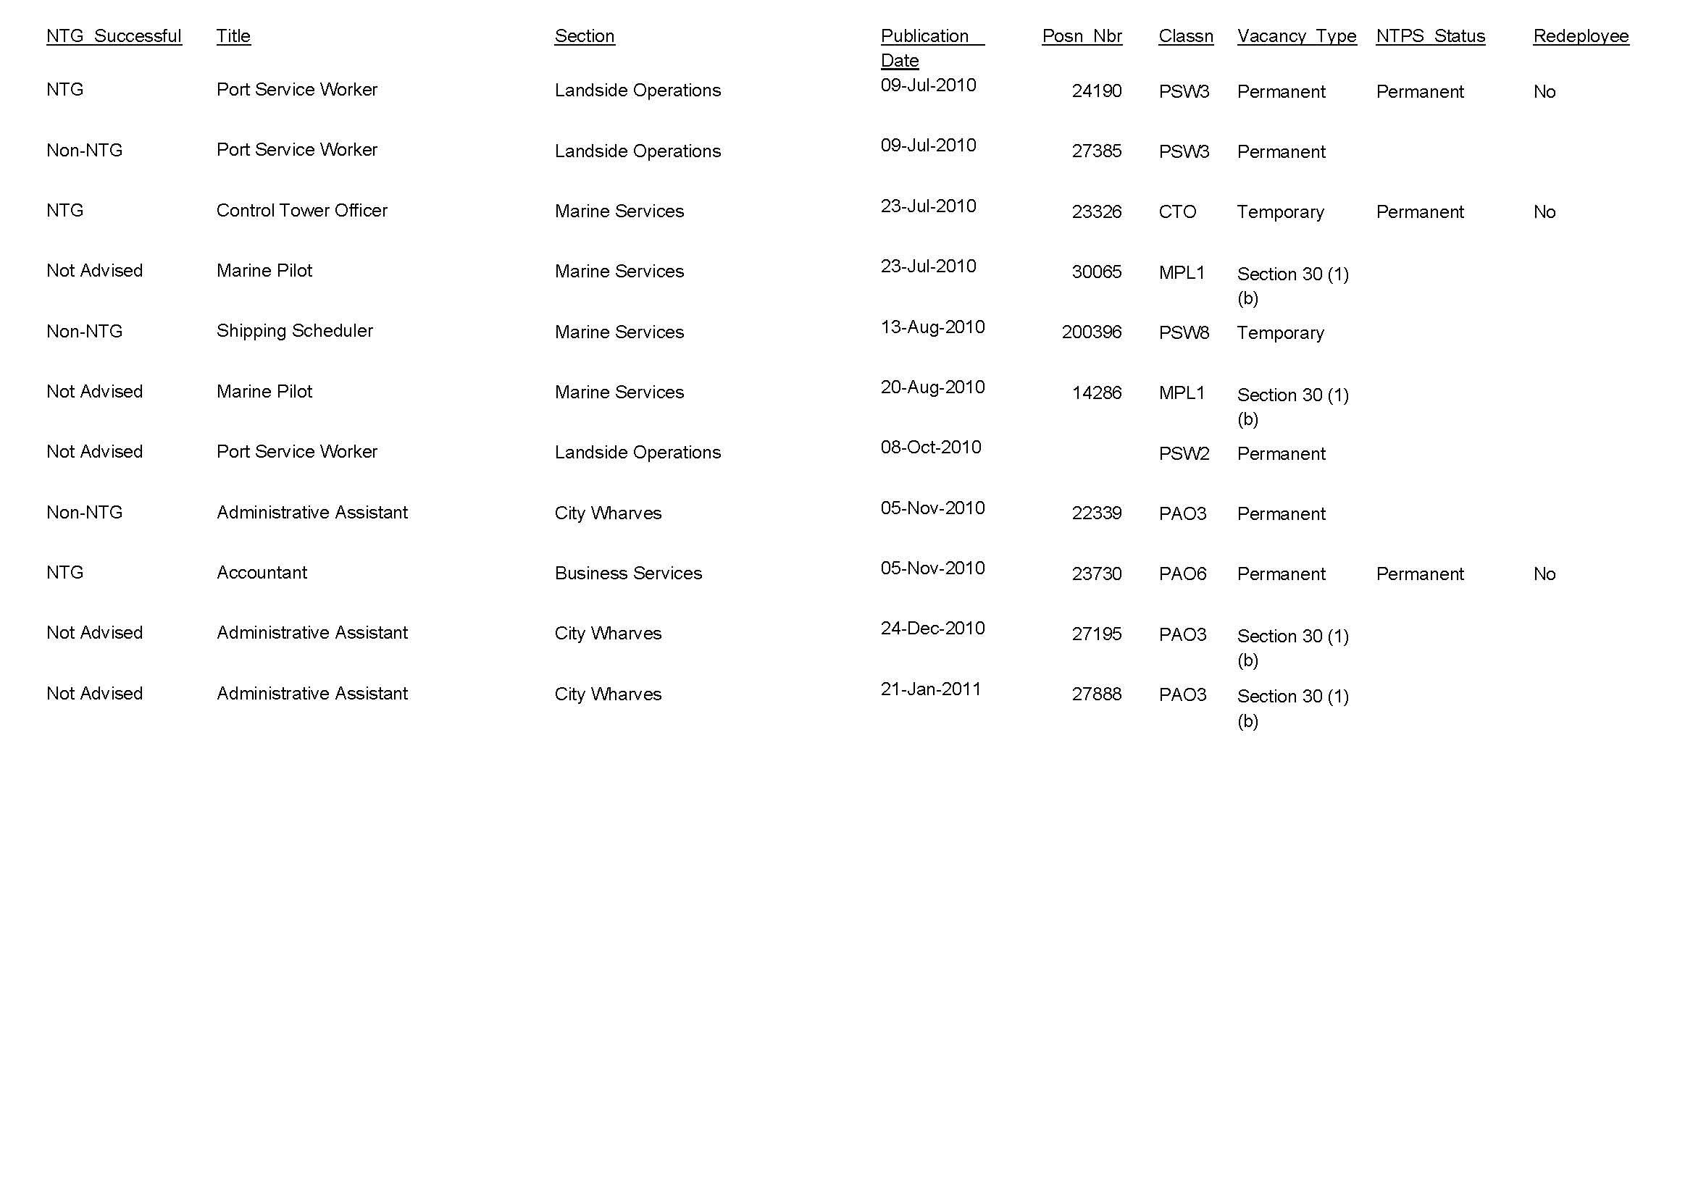

16. In 2010, how many positions have been reclassified in the department? What are the level of those positions?

Three positions have been reclassified.

One position to a higher level. This Position moved from PAO2 to PAO3

Two positions levels were unchanged follow review.

17. How many permanent supernumerary unattached employees do you have in your agency?

DPC has 3 unattached officer.

One on Six year Maternity leave
One on Extended LWOP
One on Extended temporary transfer in another NTG agency

What levels are they?

18. How many unattached employees have successfully gained nominal positions within the agency or gained employment in another agency in 2010.

Nil unattached officers have gained nominal positions within the agency or another agency.

DPC has three unattached officers.
Two employees have become unattached during 2010/2011
The third officer is unattached on Six Year Maternity Leave
One of the unattached officers is seeking to gain nominal positions.

19. How many have resigned?

Nil unattached officers has resigned.

20. What is the average length of stay of staff in the department?

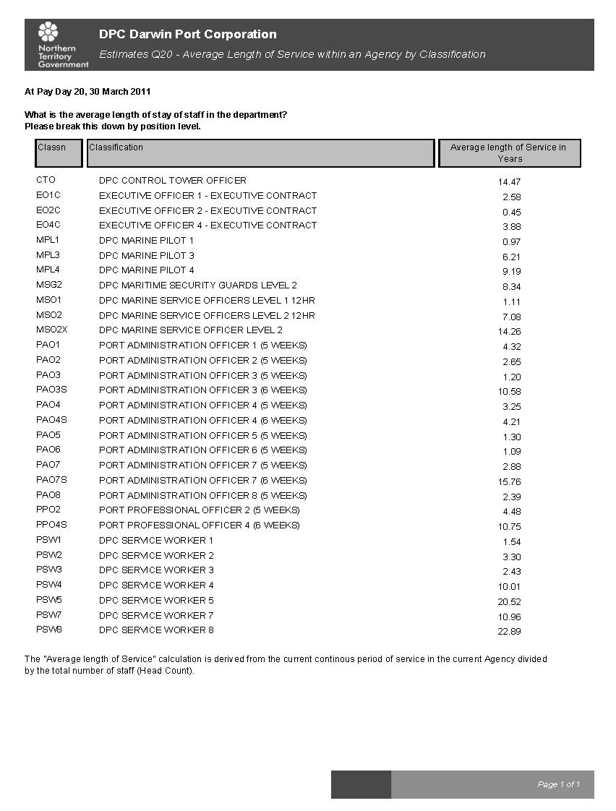

21. How much has been spent to date on advertising employee positions, and can you provide a breakdown of these costs?

A total of $6,025 has been spent up to 31/3/11 on recruitment advertising

Expenditure Type |  | Amount

General Manager Port Development 5,347
Port Service Workers $265
Control Tower Officers $150
Shipping Scheduler $133
Assistant to GMMS and HM $130
$6,025

22. In relation to Apprentices and Graduates, in 2010:
How many graduates started with the department?

Classification | Count
Graduate | 0
Apprentice | 0

DPC Electrician Harry Bliss completed his Apprenticeship in 2009 and in May 2010 was awarded the GTNT Apprentice of the Year. Harry was also a finalist in the NT Apprentice of the year.

DPC has only two Professional positions in its Established FTE

23. In relation to Indigenous Employees, in 2010:

How many employees do you have in your department that recognise themselves as indigenous? What are the levels of their positions held? How many at each level?

24. In relation to NTPS staff as of 30 March 2011:

What is the total amount of accrued leave in the department, broken down by level, long service leave and recreation leave? What is the financial value of that leave?

25. In relation to Contract (ECO1 and above) staff as of 30 March 2011:
What is the total amount of accrued leave in the department, broken down by level, long service leave and recreation leave?

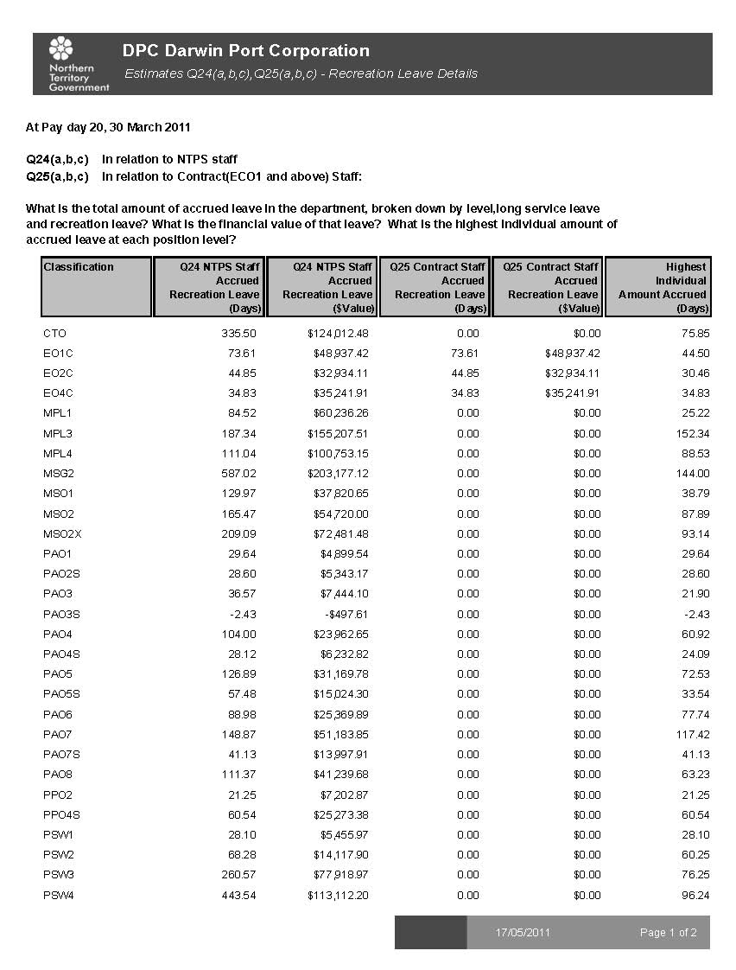

What is the highest individual amount of accrued leave at each position level?

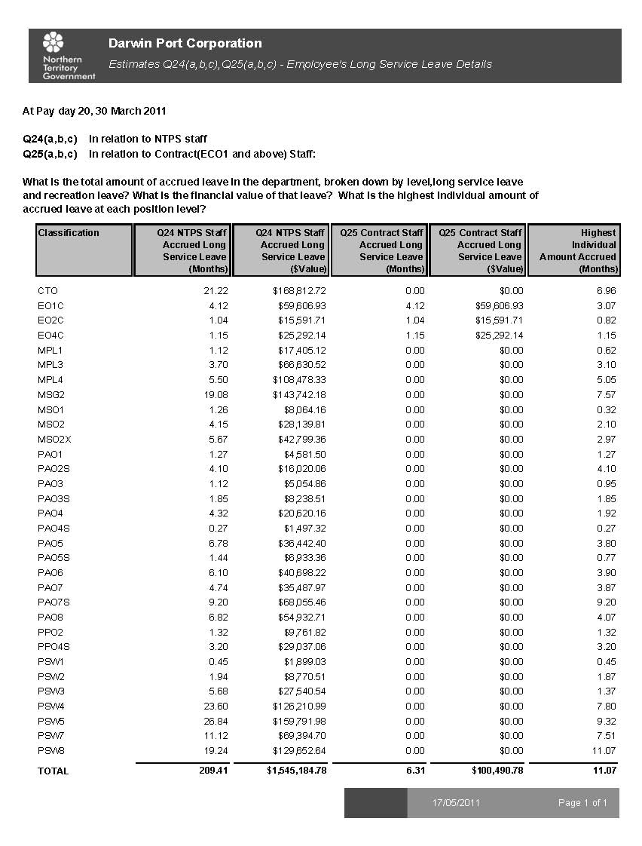

What is the current total of sick leave entitlement of employees in the department?

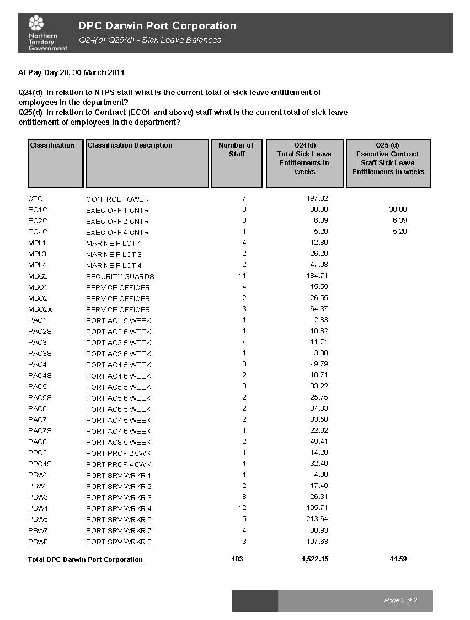

How many days sick leave were taken in 2010?

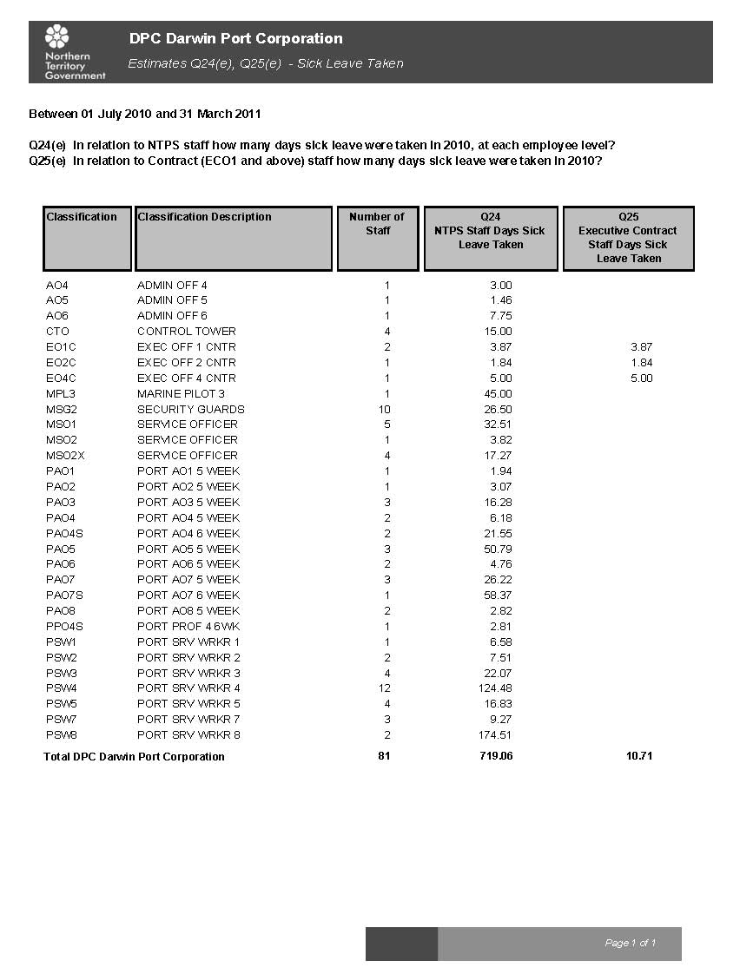

26. How many employees have utilised section 52.8 Cash-out of Leave – (Recreation Leave), under the NTPS 2010-2013 Enterprise Agreement?

DPC has a separate Enterprise Agreement and therefore does not apply.

27. How many employees have utilised section 55.3 (b) Long Service Leave cash out of 10 years, under the NTPS 2010-2013 Enterprise Agreement?

DPC has a separate Enterprise Agreement and therefore does not apply.

28. As at 30 March 2011 has the CEO directed any employee under section 52.7 Excess Leave of the NTPS 2010-2013 Enterprise Agreement to take leave?

DPC has a separate Enterprise Agreement and therefore does not apply.

29. As at 30 March 2011 has the CEO directed any employee under section 55.3 (a) Long Service Leave to take leave?

DPC has a separate Enterprise Agreement and therefore does not apply.

30. As at 30 March 2011 how many workers are currently on workers compensation? At what level and is there an expected return date?

At 30 March 2011 had one employee (PSW2) on Workers Compensation who was not fit for Duty.

The Workers Compensation Claim is for a non-current employee and is being disputed by DPC insurer via the Work Health Court.

DPC had one other employee (PSW3) on a Return to Work plan on light duties for an ongoing workers compensation claim.

31. From 30 March 2010 – 30 March 2011 how many people received workers compensation in 2010, at what position level and geographic location and how long for each person?

DPC had 14 Workers Compensation Claims during the year ended 31 March 2011.

Position Level | Lost time (days) | Location | Other information
PSW3 | 21 | Darwin
PSW4 | 2 | Darwin
PAO1 | 8 | Darwin
PSW4 | 0 | Darwin
PSW4 | 0 | Darwin
PSW5 | 1 | Darwin
PSW2 | 136 | Darwin | Disputed claim
PSW2 | 0 | Darwin
PSW4 | 0 | Darwin
PSW2 | 0 | Darwin
PSW3 | 0 | Darwin
PSW4 | 0 | Darwin
MPL1 | 0 | Darwin
PSW7 | 0 | Darwin

The Workers Compensation Claim with 136 Lost time day is for a non-current employee and is being disputed by DPC’s insurer via the Work Health Court.

DPC has one other employee (PSW3) on a Return to Work plan on light duties for an ongoing workers compensation claim.

Workers compensation claims with no lost time are principally for claims where medical treatment was required for injuries not affecting the employees ability to continue to work.

32. From 30 March 2010 – 30 March 2011 how many workers are or were on sick leave or extended leave (excluding recreation leave), longer than 3 weeks, at what level, and for what reason?

Are there any still on extended leave?

33. Do you have any personnel under the old Commonwealth superannuation scheme and if so what is the liability?

Note Treasury are answering Commonwealth Super Liability on a whole of Government basis.

34. Do they still have NTPS public servants who were employed in the 80’s and eligible for return flight to Adelaide every 2 years? How many and at what level?

35. How many complaints have been made in the Department in relation to workplace bullying and harassment?

DPC has had two Workplace Bullying and Harassment Claims.

One complaint resulted in formal process and action under PSEMA.

The second complaint resulted in formal disciplinary action and ongoing mediation.

36. From 30 March 2010 – 30 March 2011, how much has been spent on relocation cost for commencement of employment and either completion or termination of employment (removalists, airfares, accommodation and allowances) in the Department.

$100,578 has been spent to date on relocation costs for commencement of employment and either completion of termination of employment.

37. Please provide a breakdown per business unit.

79% Navigation and Pilotage
21% Corporate Services

38. How much is budgeted for relocation and other appointment and termination expenses in 2010/11.
DPC does not budget for these expenses.

39. How much was spent on travel from March 2010 to March 2011, broken down by intrastate, interstate and international fares, accommodation and other expenses?
2010-2011
ACTUAL
Domestic
Intra-Territory
Accommodation | 0
Fares | 216
Other | 0
Intra-Territory sub-total | 216
Interstate
Accommodation | 14,624
Fares | 52,754
Other | 21,036
Interstate sub-total | 88,414
International
Accommodation | 2,090
Fares | 3,841
Other | 3,020
International total | 8,951
TOTAL | 97,581

40. How much was spent on vehicles by the Department from March 2010 to March 2011?

$314,948 NT Fleet Lease Payments
$102,062 Fuel and other motor vehicles expenses

41. How many vehicles does the Department have responsibility for?

28

42. What is the change, if any, in these vehicles numbers from 2009?

An increase of 3 from March 2010

43. What proportion of those vehicles meets the emission standard of 5.5 out of 10 under the Commonwealth Government’s Green Vehicle Guide?

93%

44. How many vehicles are home garaged?

15

45. What position levels have vehicles attached or are allowed to home garage?
ECO1-4 (contract vehicles)
MPL1-4
PPO4
PSW7
PSW8
46. How many credit cards have been issued to department staff?

28

47. How many repayment transactions (and the value) for personal items and services are outstanding?

Nil

48. How many reports of the improper use of Information Technology have been made?

One

49. How many reports resulted in formal disciplinary action?

One

50. How many staff are considered ‘Essential’ in your Agency, for the purposes of an Emergency eg- Cyclone

20

Title Level
Port Management Group ECO1 x 4
Harbourmaster ECO2
Security Supervisor PSW7
Maritime Security Guards MSG2 x 2
Control Tower Officers CTO
Cargo Supervisor PSW8
PSW Supervisor PSW5
Senior Mechanic PSW5
Senior Electrician PSW5
Duty Pilot MPL3
Pilot Boat Master MSO2
Pilot Boat Masters (off duty) MSO2
Lockmaster PSW7
OHS Manager PAO7
Environmental Officer PP02

51. How much was spent by the Department in 2010 on advertising and marketing programs (and up to 1 April 2011).

$135,983

52. What was each of those programs and what was the cost of each of those programs?

Advertising $29,739
PR Marketing Consultants $50,193
Marketing & Promotion Other $56,051
Total $135,983

53. How much was spent on insurance expenses in 2010, further broken down by worker and employee insurances, physical plant and equipment insurances and other insurances?

Type of Insurance | Insurer | Total
Industrial Special Risk Insurance | Insure London & Associated Marine | $630,765
General Insurance |  | $42,479
Engineering Insurance | Vero Insurance Ltd | $2,448
Business Travel Insurance | Ace Insurance Ltd | $1,389
Public Liability Insurance | Associated Marine | $64,935
Workers Compensation Insurance | Allianz | $133,975
Total |  | $875,991

54. What areas of the department are self-insured?
What areas are commercially insured?
If there are areas that are commercially insured:
Who provides this insurance;
When is it due for renewal; and
What is the cost of this insurance provision; and
Does it attract any thresholds under which insurance is not provided or any payments on
item replacement?

The Corporation is self insured in its Property, plant and equipment used in its Community Service Obligation activities; these are assets at Frances Bay, Mooring Basin, Fisherman’s Wharf, Hornibrooks Wharf area, Fort Hill Wharf and Stokes Hill Wharf.

All other areas are commercially insured.

See question 53 for Insurer for each type

Insurance period is from 1 April to 31 March each year

Yes there are thresholds/excess for each claim which is set at different levels for each insurance class.

55. What provision has been made for disaster or major catastrophe insurance?

The DPC budgets according to the cost of insurance premium provided by the insurers each year.

56. How many tonnes of CO2 did the department emit in 2010?

Emissions from NT Fleet vehicles for 2010-11 105.50

57. What programs and strategies were introduced to reduce CO2 emissions across the department in 2010?

  - Establish annual agency fleet emission target as part of an NT Fleet target to reduce emissions by 20% over five years.
  - Introduce minimum greenhouse emission ratings of 5.5 for passenger vehicles and 3.5 for light commercial vehicles. To be reviewed after two years.
  - Introduction of functional requirement categories with agencies having to justify requests for vehicles outside the NT Fleet recommended list.
  - Introduce incentives for Executive Contractors to select more fuel efficient vehicles appropriate to level which would be cost neutral to Government.

58. Has a target for departmental CO2 emissions been set for the coming financial year.
If yes, what % reduction is that from 2010.
If no, why has a target not been set.

2%

59. What was the cost of power and water to the department in 2010?

Power $784,999
Less: Amount on charged $475,159
Net Cost $309,840

Water & Sewerage $308,098
Less: Amount on charged $88,522
Net Cost $219,577

TOTAL Net cost $529,417

60. What is the projected cost for power and water to the department in 2011?

Power $1,041,000
Less: Amount on charged $866,000
$175,000

Water & Sewerage $428,000
Less: Amount on charged $180,000
$248,000

61. List the public events/conferences/forums that were sponsored by the department from 1 January 2010 to 1 April 2011 and what are projected for 2011/12?

The DPC considers its sponsorships as a case by case basis but generally supports Port or Maritime related industries and related initiatives of its customers.

Events/Conferences/Forums sponsored by DPC from 1 January 2010 - 1 April 2011
NTLEA Sponsorship - NTLEA Golf Day 2010
Lanyard & Name Badge Sponsorship – NT Major Projects Conference 2010
Chamber of Commerce - Golf Day
Darwin Festival Sponsorship
NT Seafood 2011 Industry Awards Sponsorship
Dinah Beach Cruising Yacht Association - Wet Season Series Race Sponsorship
Informa Austral Regional Ports 2010 Event Sponsorship
Informa Austral Project Cargo Award Sponsorship
DPC Golf Day – Port Welfare Committee
Chamber of Commerce – Chief Minister’s NT Export & Industry Awards 2010

62. What is the level of sponsorship provided in terms of financial support or in kind support?

Total financial support in sponsorship for the period 1 January 2010 to a 1 April 2011 totals to $70,632.

1 in kind support was provided to the Darwin Harbour Clean-Up Day with the release of DPC staff and the loading of equipment.

63. What is the department’s budget for advertising for the 10/11 reporting year?

$120,000

64. How much is year to date expenditure? Please breakdown into newspaper, radio and TV?

Advertising | Total YTD April 2011
Newspaper | $8,866
Magazine | $57,206
TV | $479
Internet | $960
Total | $67,511

- Nil Radio advertising

- Note the above excludes Recruitment Advertising

65. What advertising campaigns have been undertaken or will be undertaken by the department in 2010/11?

No advertising campaigns have been undertaken or will be undertaken by the Corporation in 2010/11.

PROGRAM MANAGEMENT / FINANCIAL SERVICES

66. In 2010 how many consultancies were let in the year, at what cost, how many were NT firms and how many interstate and what was the value of those intra-territory and those interstate?

Period 01/07/10 to 31/05/11
NT Consultants |  | Services Provided | Value
1 | Sinclair Knight | Modify Gangway Drawing Titles & Reissue to DPC | 450
2 | Bell Gabbert Associates | 3D Modelling of SHW & Environments | 10,727
3 | KPMG | Probity Audit – SHW Management, Security & Cleaning Maintenance Tender | 4,680
4 | Herron Todd White Darwin | Annual Validation – Crustaceans Restaurant | 700
5 | Gail Humble | Conduct Client Survey | 5,640
6 | Peter & Sheila Forrest | Research Naming of Road at Darwin Business Park | 743
7 | Dept of The Chief Minister | Contribution to MBS Consultant Costs | 671,000
8 | R.B Halstead | Valuation Survey of Matthew Flinders & John Grice | 1,286
9 | Fred Marrone | Rental Valuation of Graham Baileys Fuel Site at Fisherman’s Wharf | 1,181
10 | Fred Marrone | Rental Valuation for TR Stock Pilling Site at EAW | 1,300
11 | Advanced Training | Ship Loader Training Material Development | 7,200
12 | Earl James & Associates | EA Port GIS Solution Fees | 2,196
13 | Earl James & Associates | Prepare Plans Related to Marine Supply Base | 2,040
14 | Earl James & Associates | Prepare of Easement Plan & Survey to Locate Services EAW | 810
15 | Tecon Australia | Building Permit Fee | 250
16 | Gen Air Pty Ltd | Engineering Fees – Site Measurement, Calculations & Certification | 900
 |  | TOTAL NT CONSULTANTS | 711,103

Interstate Consultant |  | Services Provided | Value
1 | Braemar Seascope | Provision of Ongoing Freight Market Forecasting for 2011 | 2,500
2 | Australian Strategic Solutions | Capacity Analysis Project | 10,573
3 | Coffey Natural | DPC Environmental Management System Development | 42,490
4 | The Consultancy Bureau | Review Pilot Salaries And Conditions Discuss Enterprise Issues | 4,200
5 | The Consultancy Bureau | Review DPC Act & BY-Laws | 58,487
6 | The Consultancy Bureau | Review Pilot Salaries and Conditions Discuss Enterprise Issues | 4,200
7 | Ernst & Young | Tax Advice Deductibility of Feasibility Studies & Prepare Income Tax | 6,952
 | Ernst & Young | Services for Period Ended 30/09/10 – Tax Effect Accounting | 8,755
 | Ernst & Young | Advice on Deductibility of All Tides & Vessels | 4,500
 | Ernst & Young | Income Tax Return 2009/2010 | 5,706
8 | AON - Perth | Insurance Valuation Review | 1,500
9 | Australian Strategic Solutions | Business Case for VTS Project | 1,072
10 | Australian Strategic Solutions | Analysis of Port Pricing Enquiry | 17,730
11 | Safety & Risk Services | ERP Folders & Response Books | 1,136
12 | Safety & Risk Services | Final ERP Manual QA | 3,902
13 | Safety & Risk Services | Emergency Response Planning Support | 20,814
14 | AMPI Darwin | Pilotage Safety Management Review | 5,810
15 | Stuart Proctor | Pilotage Consultancy Services | 2,612
16 | IXSurvey Australia | Annual Re-survey of East Arm Berths | 13,090
17 | XSurvey Australia | Darwin Port Tide Levels & GPS Relationship | 13,090
18 | Ferriby Group of Companies Pty Ltd | Bridge Resource Management Audit | 5,158
19 | AJ Auditing Services | QA Surveillance Audit | 1,325
20 | AJ Auditing Services | Proportion of Expenses Associated with May 2010 Audit | 353
21 | AJ Auditing Services | QA Surveillance Audit | 1,759
 |  | TOTAL INTERSTATE CONSULTANTS | 237,714
 |  | TOTAL NT & INTERSTATE CONSULTANTS | 948,817

